 |  | RCSJTA TT CR_008 R3  Video Share API
Meeting Information
Meeting Name and Number
Meeting Date
Meeting Location
Document Information
Document Author(s) |  | Jean-Marc AUFFRET
Document Creation Date |  | 30/08/2013
 |  | Approval | X
This document is for: (mark X as appropriate) |  | Discussion
 |  | Information only
Security Classification – Non Confidential / Confidential GSMA Material (Delete as appropriate and delete the rows below that do not apply) |  |  | Can be distributed to: (mark X as appropriate or specify group
Non Confidential |  | Public
Confidential |  | Project Team or Group | X
Confidential |  | GSMA HQ Staff | X
Confidential |  | GSMA Full Members | X
Confidential |  | GSMA Associate Members | X
Confidential |  | GSMA Rapporteur Members | X
Document Summary
CR for Blackbird release.

Document History
Date | Version | Author / Comments and for updates description of changes
30/08/2013 | R1 | Jean-Marc AUFFRET (jeanmarc.auffret@orange.com)
11/09/2013 | R2 | Jean-Marc AUFFRET (jeanmarc.auffret@orange.com)
26/09/2013 | R3 | Jean-Marc AUFFRET (jeanmarc.auffret@orange.com)

© GSMA 2010. The GSM Association (“Association”) makes no representation, warranty or undertaking (express or implied) with respect to and does not accept any responsibility for, and disclaims liability for the accuracy or completeness or timeliness of the information contained in this document. The information contained in this document may be subject to change without prior notice. This document has been classified according to the GSMA Document Confidentiality Policy. GSMA meetings are conducted in full compliance with the GSMA Antitrust Policy.

RCC TF Change Request Form
Title: | 3.4.6 Video Share API
Type of Change Request: Mark the appropriate box by “X” | New Feature |  | Major  Change Errata
  X
Targeted Document | joyn Terminal API Specification
Impact on Other Official Documents: | None

======================= Summary of Changes ==================================

30/08/2013 – Update API after Albatros implementation.
11/09/2013 – Add VideoPlayerListener and VideoRendererListener specification.
26/09/2013 – Add Qualcomm comments.

======================= End of Summary ==================================

======================= 1st Change ==================================

Video Share API
This API exposes all functionality related to sharing live video stream during a CS call via the Video Share Service. It allows:
- Send a video share request.
- Receive notifications about incoming video share invitation and sharing events.
- Cancel an ongoing video share.
- Accept/reject an incoming video share request.
- Read configuration elements affecting video share.

Package
Package name org.gsma.joyn.vsh

Methods and Callbacks
Class VideoSharingService:
This class offers the main entry point to share live video during a CS call, when the call hangs up the sharing is automatically stopped. Several applications may connect/disconnect to the API.
Method: connects to the API.
void connect()
Method: disconnects from the API.
void disconnect()
Method: returns the list of video sharing in progress.
Set<VideoSharing> getVideoSharings()
Method: returns a current video sharing from its unique ID.
VideoSharing getVideoSharing(String sharingId)
Method: returns a current video share from its invitation Intent.
VideoSharing getVideoSharingFor(Intent intent)
Method: shares a live video stream with a contact. The parameter contact supports the following formats: MSISDN in national or international format, SIP address, SIP-URI or Tel-URI. The parameter player contains a media player which streams over RTP the live video from the camera. The media player is just an interface which permits to have a player implementation independants from the joyn API. An exception if thrown if there is no ongoing CS call.
VideoSharing shareVideo(String contact, VideoPlayer player, VideoSharingListener listener)
Method: returns the configuration for video share service.
VideoSharingServiceConfiguration getConfiguration()
Method: adds a new video share invitation listener.
void addNewVideoSharingListener(NewVideoSharingListener listener)
Method: removes a new video share invitation listener.
void removeNewVideoSharingListener(NewVideoSharingListener listener)

Class VideoSharing:
This class maintains the information related to a video sharing and offers methods to manage the sharing.
Method: returns the sharing ID of the video sharing.
String getSharingId()
Method: returns the remote contact.
String getRemoteContact()
Method: returns the video encoding (e.g. H264).
String getVideoEncoding()
Method: returns the video format (e.g. QCIF).
String getVideoFormat()
Method: returns the state of the video share. The state may have the following values: INVITED, INITIATED, STARTED, TERMINATED, ABORTED, FAILED.
int getState()
Method: returns the direction of the sharing: INCOMING, OUTGOING.
int getDirection()
Method: accepts video share invitation with a given renderer.
void acceptInvitation(VideoRenderer renderer)
Method: rejects video share invitation.
void rejectInvitation()
Method: aborts the sharing.
void abortSharing()
Method: adds a listener on video sharing events.
void addEventListener(VideoSharingListener listener)
Method: removes a listener from video sharing.
void removeEventListener(VideoSharingListener listener)

Class VideoSharingListener:
This class offers callback methods on video sharing events.
Method: callback called when the sharing is started.
void onSharingStarted ()
Method: callback called when the sharing has been aborted.
void onSharingAborted()
Method: callback called when the sharing has failed. The error code may be: INVITATION_DECLINED, SHARING_FAILED.
void onSharingError(int error)

Class VideoPlayer:
This class offers an interface to manage the video player instance independently of the joyn service. The video player is implemented in the application side.
Method: opens the player and prepares resources (e.g. encoder, camera).
void open(VideoCodec codec, String remoteHost, int remotePort)
Method: closes the player and deallocates resources.
void close()
Method: starts the player.
void start()
Method: stops the player.
void stop()
Method: returns the local RTP port used to stream video.
int getLocalRtpPort()
Method: returns the list of codecs supported by the player.
VideoCodec[] getSupportedCodecs()
Method: adds a listener on video player events.
void addEventListener(VideoPlayerListener listener)
Method: removes a listener from video player.
void removeEventListener(VideoPlayerListener listener)

Class VideoPlayerListener:
This class offers callback methods on video player events.
Method: callback called when the player is opened.
void onPlayerOpened()
Method: callback called when the player is started.
void onPlayerStarted()
Method: callback called when the player is stopped.
void onPlayerStopped()
Method: callback called when the player is closed.
void onPlayerClosed()
Method: callback called when the player has failed.
void onPlayerFailed()

Class VideoRenderer:
This class offers an interface to manage the video renderer instance independently of the joyn service. The video renderer is implemented in the application side.
Method: opens the renderer and prepares resources (e.g. decoder, display).
void open(VideoCodec codec, String remoteHost, int remotePort)
Method: closes the renderer and deallocates resources.
void close()
Method: starts the renderer.
void start()
Method: stops the renderer.
void stop()
Method: returns the local RTP port used to stream video.
int getLocalRtpPort()
Method: returns the list of codecs supported by the renderer.
VideoCodec[] getSupportedCodecs()
Method: adds a listener on video renderer events.
void addEventListener(VideoRendererListener listener)
Method: removes a listener from video renderer.
void removeEventListener(VideoRendererListener listener)

Class VideoRendererListener:
This class offers callback methods on video renderer events.
Method: callback called when the renderer is opened.
void onRendererOpened()
Method: callback called when the renderer is started.
void onRendererStarted()
Method: callback called when the renderer is stopped.
void onRendererStopped()
Method: callback called when the renderer is closed.
void onRendererClosed()
Method: callback called when the renderer has failed.
void onRendererFailed()

Class VideoCodec:
This class maintains the information related to a video codec.
Method: returns the encoding name (e.g. H264).
String getEncoding()
Method: returns the codec payload type (e.g. 96).
int getPayloadType()
Method: returns the codec clock rate (e.g. 90000).
int getClockRate()
Method: returns the codec frame rate (e.g. 10).
int getFrameRate()
Method: returns the codec bit rate (e.g. 64000).
int getBitRate()
Method: returns the video width (e.g. 176).
int getVideoWidth()
Method: returns the video height (e.g. 144).
int getVideoHeight()
Method: returns a codec parameter from its key name (e.g. profile-level-id, packetization-mode).
String getParameter(String key)

Class VideoSharingServiceConfiguration:
This class represents the particular configuration of Video Sharing Service.
Method: returns maximum authorized duration of the content that can be shared in a VSH session. It can return null if this value was not set by autoconfiguration server.
int getMaxTime()

Intents
Intent broadcasted when a new video sharing invitation has been received. This Intent contains the following extras:
- “contact”: MSISDN of the contact sending the invitation.
- “contactDisplayname”: display name of the contact sending the invitation (extracted from the SIP address).
- “sharingId”: unique ID of the sharing.
- ”encoding”: video encoding (e.g. H264).
- “format”: video format (e.g. QCIF).
org.gsma.joyn.vsh.action.NEW_VIDEO_SHARING

Content Providers
A content provider is used to store the video sharing history persistently. There is one entry per video sharing.
The content provider has the following columns:

Data | Data type | Comment
SHARING_ID | TEXT | Unique sharing identifier
CONTACT_NUMBER | TEXT | Contains the MSISDN of the remote contact
DIRECTION | Integer | Incoming sharing or outgoing sharing
TIMESTAMP | Long | Date of the sharing
STATE | integer | See note below for the list of states
DURATION | Long | Duration of the sharing in seconds. The value is only set at the end of the sharing.

Note :

State values for video sharing session management :

- INVITED : incoming session.
- INITIATED : outgoing session.
- STARTED : invitation has been accepted and sharing is started.
- ABORTED: session has been aborted.
- TERMINATED: session has been terminated.
- FAILED : session has failed.

Sequence diagrams
The following diagrams explain the interactions between the video player or video renderer instanciated by the application and the joyn API.

Originating side:
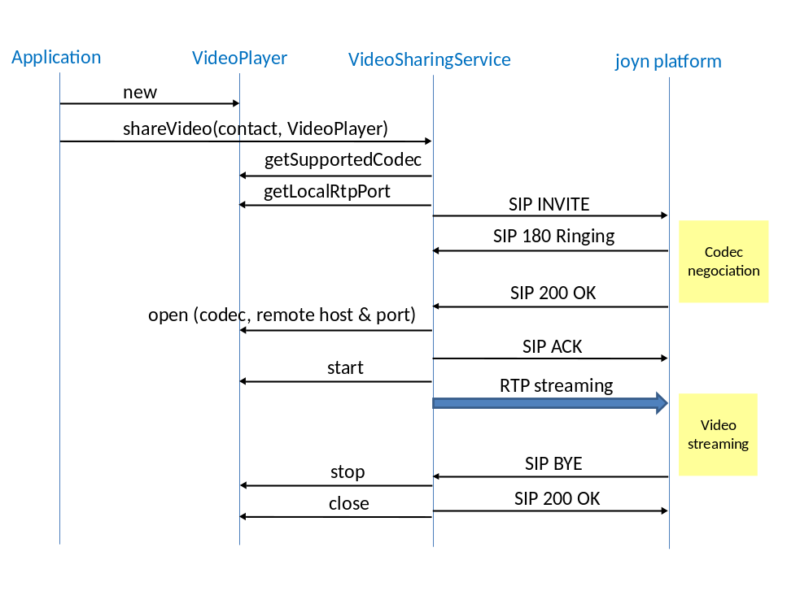
Terminating side:
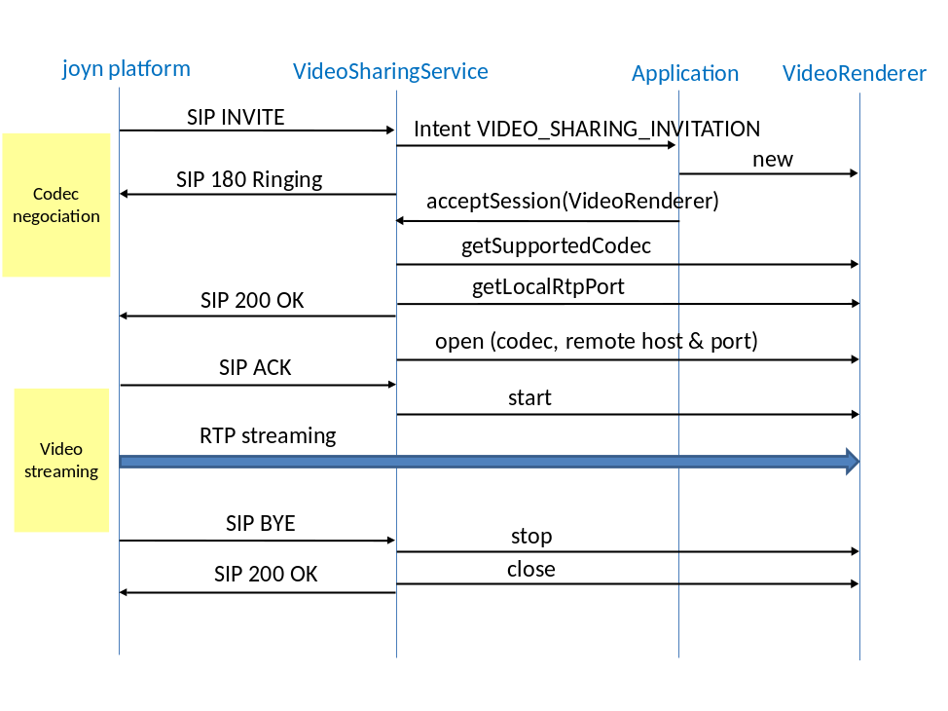

======================= End of changes==================================

